Exercise 16: Mongoose population

Objective
In this exercise, you’ll learn about Mongoose population. It is a powerful feature that lets you automatically replace specified paths in a document with documents from other collections. This process is somewhat similar to performing a "join" in a relational database. Population can help simplify your data architecture by allowing you to store references to other documents instead of duplicating data.

Exercise
- Using node-mongoose app
- Change code in article.js (models folder) as below
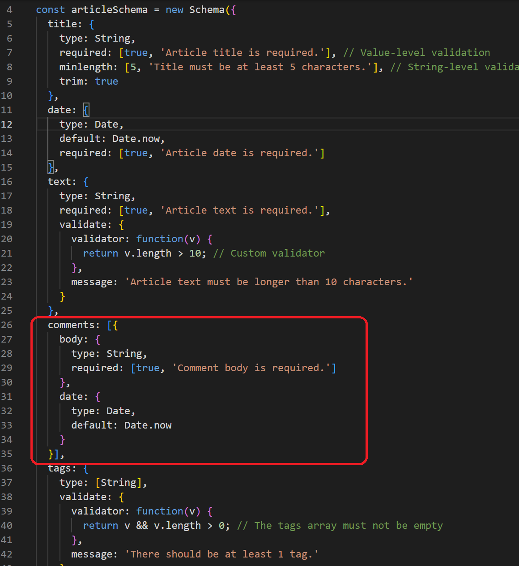

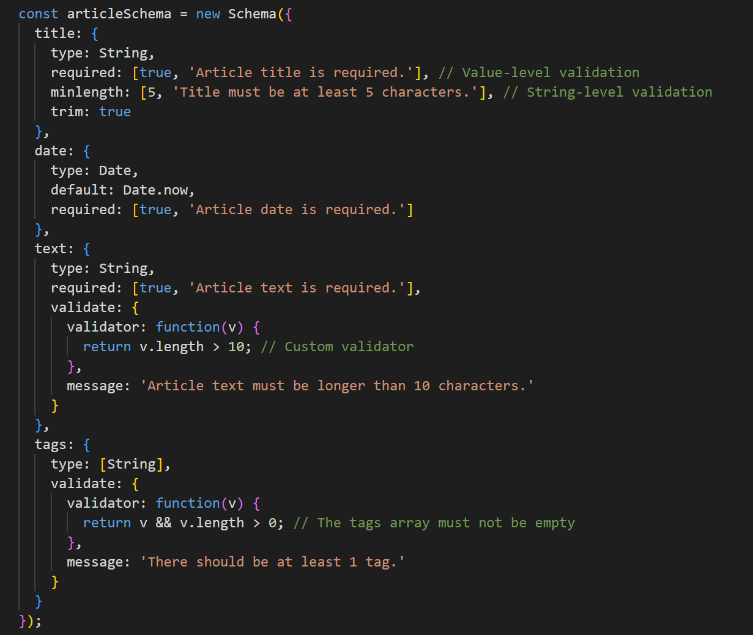
- Create comment.js in models folder
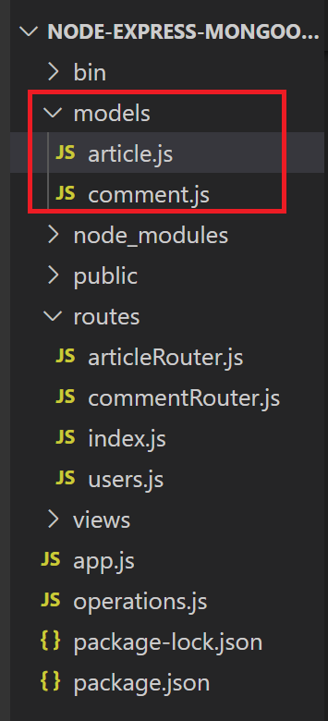
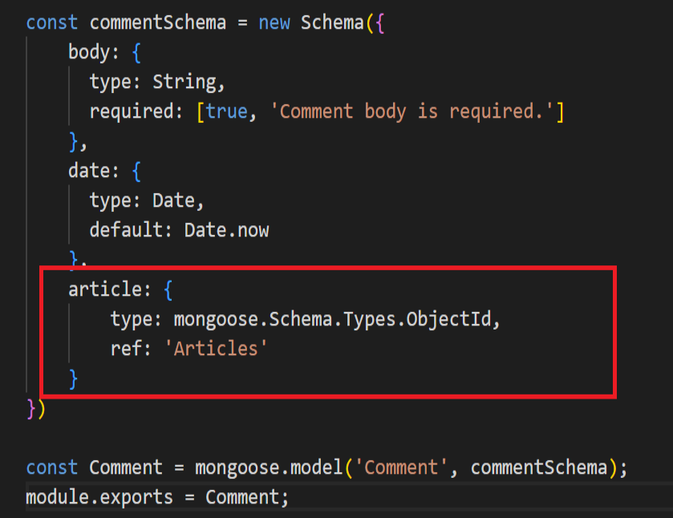
- Create commentRouter.js in routes folder

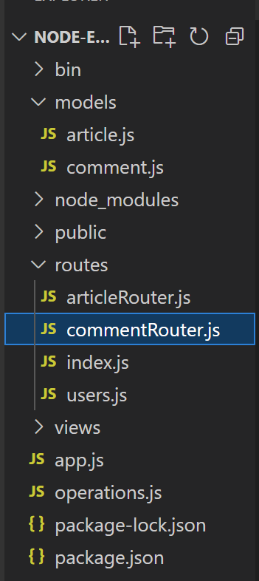

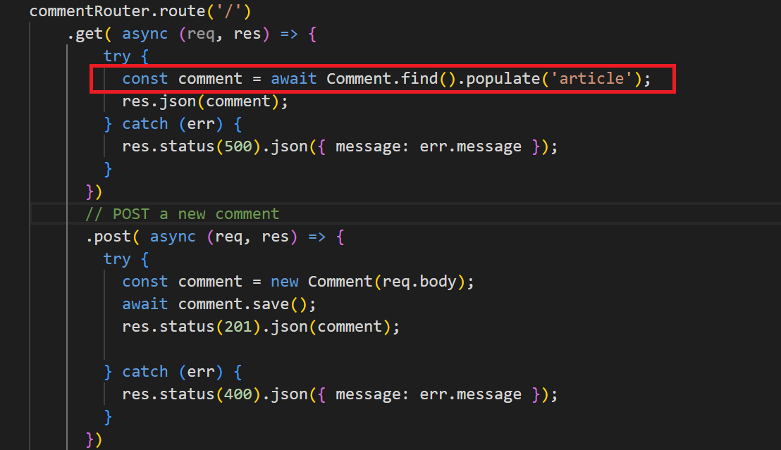
- Test with Postman
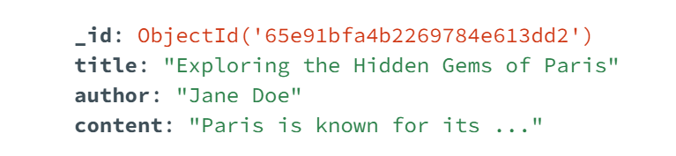
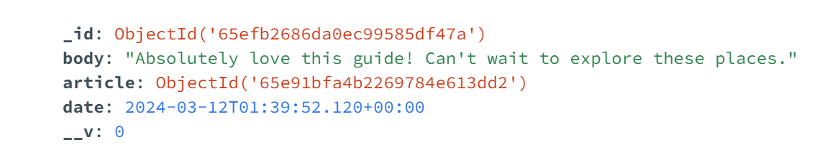
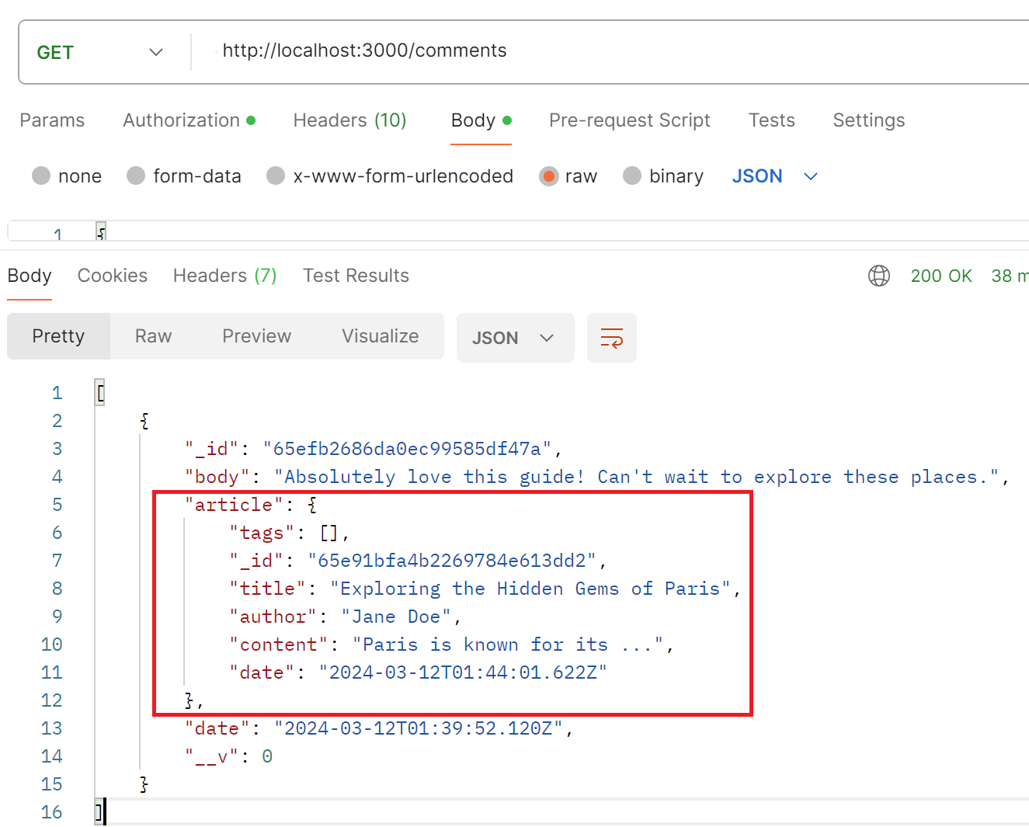

Conclusion
After doing this exercise, you are able to manage relationships between documents across different collections. By effectively using population, you can streamline data retrieval processes and maintain a clean data structure in your MongoDB applications.

